Survive The System - TOMBOLA

Link all Trophic connections (with a RED line) and all Mutualistic/Symbiotic Interactions (with a BLUE line) between all life forms you found in the Game.
Good answer will be selected to win a huge Toblerone. =]
An Email will be sent to the winner today after 4PM













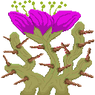



Your email Adress*:
Do you wish to join the mailing list? [Yes/No] :
Do you wish to participate to the Tombola? [Yes/No] :

*Your email address will only be used for sharing news about the game, if yes is selected at the next question

